**POWER BI PROTFOLIO PROJECT**

**Business Intelligence Case Study: Flying Whale Airline Background**

Flying Whale Airline, a prominent (fictional) international airline, is seeking to enhance its business intelligence capabilities by Analyzing Customer Flight Activity and Customer Loyalty History. The airline is committed to optimizing customer experience, understanding travel patterns, and maximizing the effectiveness of its loyalty programs. Data: You have access to two key datasets:

1. **Customer Flight Activity:**
   * Loyalty Number: A unique identifier for each customer's loyalty account.
   * Year and Month: Period details for analysis.
   * Flights Booked: Number of flights booked by the member during the period.
   * Flights with Companions: Number of flights booked with additional passengers.
   * Total Flights: Combined total of Flights Booked and Flights with Companions.
   * Distance: Flight distance traveled in kilometers during the period.
   * Points Accumulated: Loyalty points earned in the period.
   * Points Redeemed: Loyalty points redeemed during the period.
   * Dollar Cost Points Redeemed: Dollar equivalent for points redeemed in Canadian Dollars (CDN).
2. **Customer Loyalty History:**
   * Loyalty Number: A unique identifier for each customer's loyalty account.
   * Demographics: Country, Province, City, Postal Code, Gender, Education, Salary, Marital Status.
   * Loyalty Card: Current loyalty card status
   * Customer Lifetime Value (CLV): Total invoice value for all flights ever booked by the member.
   * Enrollment Details: Enrollment Type (Standard / 2018 Promotion), Enrollment Year, Enrollment Month.
   * Cancellation Details: Cancellation Year and Month if applicable.

**3.Business Scenarios:**

1. **Flight Activity Analysis:**

**Analyze monthly and yearly flight booking patterns.**

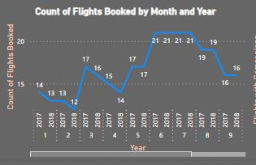

**Explore the correlation between flight distances and loyalty points accumulated.**

There is a positive correlation between flight distances and loyalty points accumulated.

**Including a trend line and a max line:**

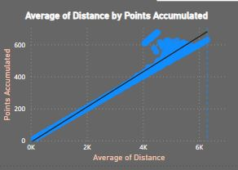

**Assess the impact of companion bookings on loyalty points redeemed.**

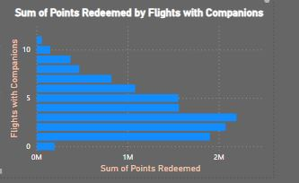 Visual says that the impact of companion bookings on loyalty points redeemed is huge, i.e. 198967.

**What is the number of companions where members are redeeming the most points?**

Flights with companion 3 redeeming the most points, i.e. 2195087.

1. **Loyalty Segmentation:**

**Segment customers based on loyalty card status.**

Based on loyalty card status ,20% are “Aurora”, 45% are “Star” and 34% are “Nova”.

**Show Total number of flights by Loyalty Card across months.**

In July (Star card) there was a maximum number of flights booked i.e., 112219.

**Analyze the demographics and behaviors of customers.**

From the visuals, we can say that customers with “Star and Nova loyalty cards” have booked the greatest number of flights specially in the month of “July.”

**Depict Number of loyalty members by marital status**

From the visuals, we can depict that max Loyalty members are “Married.” These are 9.74K.

**Show flights booked by loyalty card and broken up by gender.**

I can interpret that “star loyalty card holders” have booked maximum number of flights.

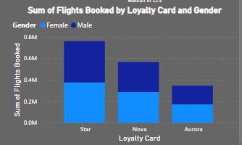

**Show median distance travelled by different loyalty card tiers.**

* + - Aurora => median distance travelled is 543
    - Star => median distance travelled is 536
    - Nova => median distance travelled is 491

**Narrative visual to autogenerate insights.**

* ﻿Married had the highest Loyalty Number at 9,735, followed by Single at 4,484 and divorced at 2,518.
* Star had the highest average Sum of Flights Booked at 63,271.67, followed by Nova at 47,071.67 and Aurora at 28,753.67.
* July in Loyalty Card Star made up 5.31% of Sum of Flights Booked.
* ﻿Star had the highest total Sum of Flights Booked at 759260, followed by Nova at 564860 and Aurora at 345044.

**Identify trends in Customer Lifetime Value (CLV) across loyalty segments.**

Median of Loyalty car for three different tiers is different. CLV for Aurora card holders is huge than any other.

**Answer the question:**

**Which credit card tier on average has customers with the highest Customer Lifetime Value?**

“Aurora” has the highest CLV.

**Tips**

**Create a table Customer Loyalty Cancellation for loyalty members that have cancelled.**

**Query:**

Cancellation Table = SELECTCOLUMNS('Customer Loyalty History',

 'Customer Loyalty History'[Loyalty Number],

 'Customer Loyalty History'[Enrollment Month],

 'Customer Loyalty History'[Enrollment Year],

 'Customer Loyalty History'[Cancellation Month],

 'Customer Loyalty History'[Cancellation Year]

)

**Create two new columns in the new table Enrollment Duration (e.g. 2 years 1 month) and Enrollment Duration (Months) (e.g. 25)**

**Query:**

**Enrollment Duration (e.g. 2 years 1 month):**

Enrollement (Years,Months) Duration = IF(ISBLANK('Cancellation Table'[Cancellation Date]),BLANK(),

 var Years = INT('Cancellation Table'[Enrollement Duration Month]/12)

    var Months = MOD('Cancellation Table'[Enrollement Duration Month],12)

    RETURN

    IF(Years>0 && Months>0,

        Years & " Years " & Months&" Months",

            IF(Years>0,

                Years & " Years ",Months &" Months"

            )

    )

)

**Enrollment Duration (Month):**

Enrollement Duration Month = DATEDIFF('Cancellation Table'[Enrollement Date],'Cancellation Table'[Cancellation Date],MONTH)

**Create two new columns in Customer Loyalty History Table Enrollment Duration (Till Date) and Enrollment Duration (Till Date) Months:**

**Query:  
  
Enrollment Duration (Till Date):**

Enrollment Duration(Till Date)MonthsYears =

VAR Years = INT(DIVIDE('Cancellation Table'[Enrollment Duration(Till Date) Months],12))

VAR Months = MOD('Cancellation Table'[Enrollment Duration(Till Date) Months],12)

RETURN

    IF(Years>0 && Months>0,

        Years & " Years " & Months & " Months",

            IF(Years>0, Years & " Years ",

                Months & " Months"

            )

    )

**Enrollment Duration (Till Date) Month:**

Enrollment Duration(Till Date) Months =

    DATEDIFF(

        'Cancellation Table'[Enrollement Date],

TODAY(),

MONTH

        )

**These columns should count the time a member has been enrolled till today or till they cancelled whatever comes first.**

**Query:**

Enrollment Duration(TillDate)or(TillCancelled) = VAR EnrolledMonths=

IF(

ISBLANK('Cancellation Table'[Customer Loyalty History_Cancellation Month]), DATEDIFF('Cancellation Table'[Enrollement Date],TODAY(),MONTH), DATEDIFF('Cancellation Table'[Enrollement Date],'Cancellation Table'[Customer Loyalty History_Cancellation Month],MONTH)

)

VAR Years=

INT(DIVIDE(EnrolledMonths,12)) VAR Months =

MOD(EnrolledMonths,12) RETURN

IF(Years>0 && Months>0,

Years &" Years " & Months & " Months", IF(

Years>0,

Years & " Years ", Months & " Months"

)

)

**Answer the following:**

**Provide information for average duration of enrollment among cancelled members by province.**

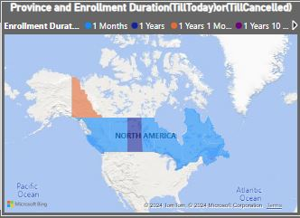

**Which province sees members cancelling the fastest? Bonus: Depict this information on a map**

**Ontario** saw the members cancel their membership the fastest.

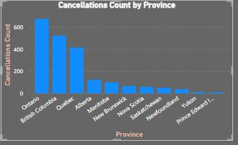

**Most popular months for cancellations**

December i.e., 213

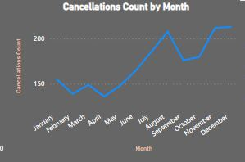

**Cancellations by education and marital status. Which demographic is cancelling the most?**

Education “Bachelors and Married” are people with highest count of cancellation.

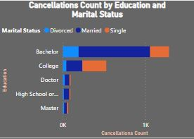

**Which loyalty card members have the lowest enrollment duration among cancellations?**

Arora has 449.

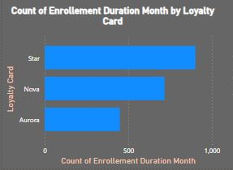

**Dashboards:**

**Flight Activity Analysis:** 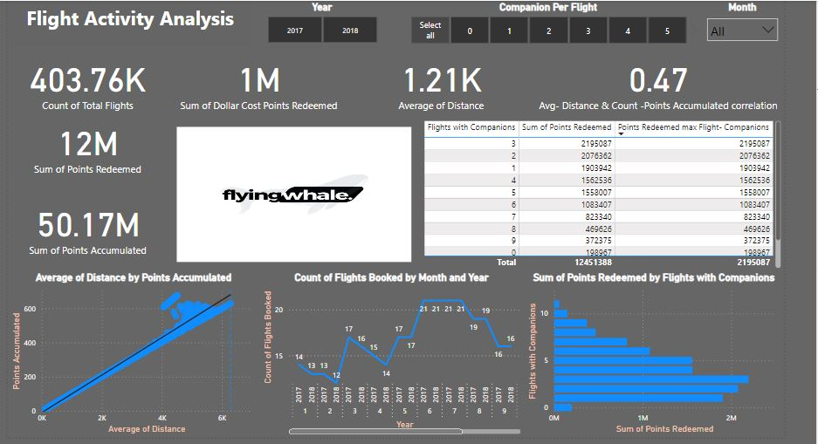

**Loyalty Segmentation:**

**Enrollment and Cancellation Trends:**

